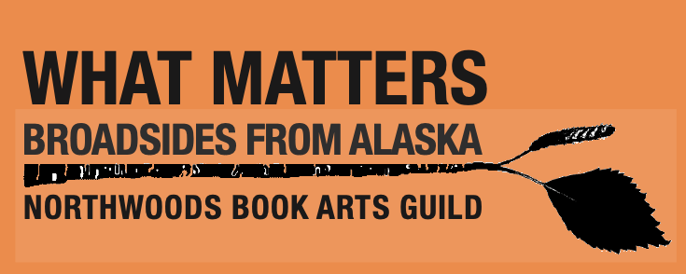

Broadside Poetry Submission Guidelines
- Poems may be submitted by poets who are members of Northwoods Book Arts Guild or 49 Writers. We intend to accept poetry for this project through June 2027.
- Poems must relate to the project theme: What Matters: Broadsides from Alaska
- Multiple submissions are allowed, but not simultaneously.
- The submission is reviewed by the curatorial committee and selected by an artist to create an image that responds to the poem.
- Poems must be original work of the poet and not previously published. Excerpts of longer poems are allowed. AI assistance is not allowed.
- Poem length should be from 8 to 24 lines including spaces between stanzas. The title does not count. Epigraphs do count.
- Submissions should be sent in Georgia 12 pt. in a docx file format.
- Poems will remain anonymous until they are processed and selected. Do not include your name on the poem file you submit.
- Poets submit a fee of $40.00 at the time the poem is chosen for inclusion in the broadside project. Fee includes opportunity to collaborate, a copy of the catalog of What Matters: Broadsides from Alaska, and inclusion in one or more exhibitions.
- The poet will have the opportunity to collaborate, if desired, with the artist (who creates the image), the designer (who creates the layout), and the print team that prints the broadside. Note that the roles of artist, designer, and print team may involve one or more people.
- The poem copyright will revert to the poet after broadside publication.
- To Submit please use this link https://docs.google.com/forms/d/e/1FAIpQLScPU_ln9mtpzZtkp9K0t2ruWwktQI-iQGPHyS1SbXfCVgVC9g/viewform

